Assessment Policy
Kildimo National School, 2020

Introduction & Rationale:
This policy was originally drafted in 2007 during a school planning day using the expertise of the School Development Planning Service facilitator. The policy was redrafted in May 2020 and was ratified by the Board of Management in _________ 2020.
This policy is a record of the assessment approaches being used by the staff of Kildimo N.S., informed and guided by the NCCA ‘Assessment in the Primary School Curriculum: Guidelines for Schools’ (2007) and the DES ‘Literacy and Numeracy: For Learning and Life’ (2011).
Assessment is defined as ‘the process of gathering, interpreting, using and reporting information about a child’s progress and achievement in developing knowledge, skills and attitudes’ (NCCA, 2007: 23). In Kildimo N.S. we acknowledge the importance of using and interpreting the assessment information that we gather to inform our future teaching. We acknowledge that assessment is an integral part of the teaching and learning cycle as illustrated in the diagram below:

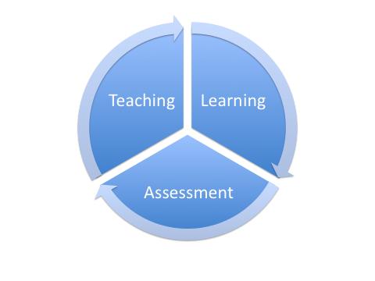

Using assessment as part of teaching and learning, the teacher…
- Shares with the children what their new learning will involve
- Explores with the children what successful learning looks like
- Uses appropriate methodologies and classroom organizational strategies
- Gathers and records information about what and how children are learning
- Plans new learning using assessment information and curriculum objectives (NCCA, 2007: 8)
Assessment is divided into two principal approaches:
- Assessment for Learning (AfL): ‘The teacher uses evidence on an ongoing basis to inform teaching and learning’ (NCCA, 2007: 8). AfL is also known as formative assessment.
- Assessment of Learning (AoL): ‘The teacher periodically records children’s progress and achievement for the purpose of reporting to parents, teachers and other relevant persons’ (NCCA, 2007: 8). AoL is also known as summative assessment.
In Kildimo N.S., we recognise that these two approaches are interrelated and complementary and both are central to our work as teachers.
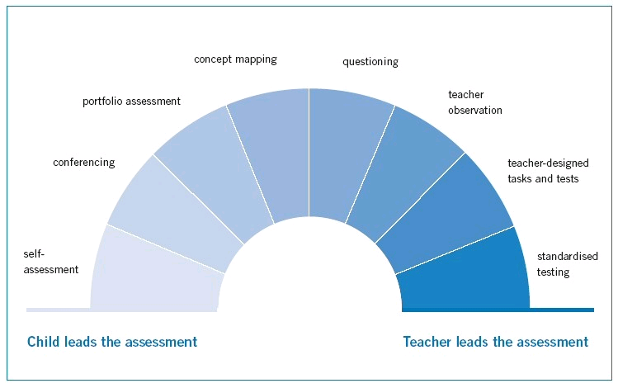
The image above is referred to as ‘A Continuum of Assessment Methods’ (NCCA, 2007: 13).
There are eight methods of assessment presented on the continuum. Methods positioned towards the left are those in which the child plays a leading role in assessing his/her own work. Methods towards the right of the continuum involve the teacher playing a central role in leading the assessment.
Relationship to School Ethos:
The school adopts a holistic approach to the education and development of each child, the enhancement of teaching processes. An effective Assessment policy identifies early interventions that need to be put in place to ensure that enhancement, increased confidence and raised self-esteem is achieved.
Aims:
The staff of Kildimo N.S. will endeavour:
- To benefit pupil learning
- To inform teaching
- To generate baseline data that can be used to monitor achievement over time
- To involve parents and pupils in identifying and addressing learning strengths or difficulties
- To facilitate improved pupil learning
- To create a procedure for monitoring achievement by building a picture over time of a child’s progress and achievement in learning across the curriculum.
- To assess a child’s progress in literacy, numeracy and other curricular areas through a variety of assessment approaches in the mainstream setting
- To utilise assessment as a diagnostic tool in the Special education setting
- To utilise the range of assessment approaches as outlined in the NCCA Assessment Guidelines
- To utilise assessment as a tool to inform future teaching and learning in our individual classes
- To track learning processes which assist the long- and short-term planning of teachers
Policy Content:
This policy acknowledges the need for informal and formal assessment
This policy is geared towards using assessment to inform planning and identify the needs of all pupils, including the exceptionally gifted so that adequate strategies are put in place early enough to facilitate remediation. These strategies may include pupil self-assessment, pupil profiling, communication between parents and teachers, modification of teacher programmes and individual education plans.

Continuum of Support
The Department has set out the Continuum of Support framework to assist schools in identifying and responding to students’ needs. This framework recognises that special educational needs occur along a continuum, ranging from mild to severe, and from transient to long term, and that students require different levels of support depending on their identified educational needs. Using this framework helps to ensure that interventions are incremental, moving from class-based interventions to more intensive and individualised support, and that they are informed by careful monitoring of progress.
The Continuum of Support is a problem-solving model of assessment and intervention that enables schools to gather and analyse data, as well as to plan and review the progress of individual students.

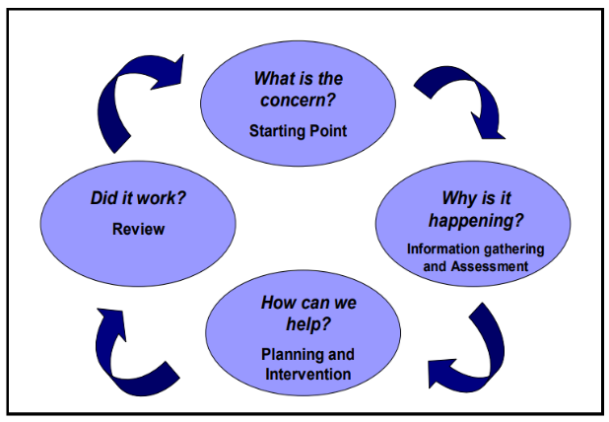

Using the Continuum of Support framework, schools can identify students’ educational needs, to include academic, social and emotional needs, as well as needs associated with physical, sensory, language and communication difficulties. The framework emphasises the importance of looking at a student’s needs in context, and provides useful resources to support this (for example, Learning Environment Checklist, Teacher Checklist for Whole-Class Structures and Supports).
The Continuum of Support enables schools to identify and respond to needs in a flexible way. This means that needs can be responded to as early as possible. Of course, the principle that pupils with the greatest level of need have access to the greatest levels of support is of primary importance. This approach is also supported by information and engagement with external professionals, as required.
The following levels of support are suggested:

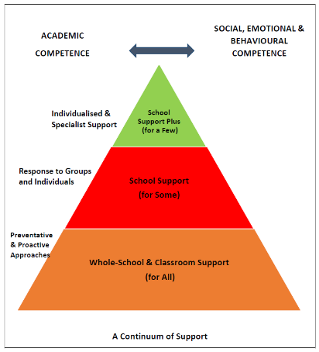
Appendix (1) outlines how a school can collect evidence about students’ educational needs at each level of the Continuum of Support. This evidence can then be used to adapt teaching, to plan the next steps in students’ learning and to gauge their responses to intervention. When data and information are carefully collected, shared and compared, schools can identify and respond to those students who have special educational needs

NEPS Model of Service & Further Assessment
In common with many other psychological services and best international practice, the National Educational Psychological Service (NEPS) has adopted a consultative model of service. The focus is on empowering teachers to intervene effectively with pupils whose needs range from mild to severe and transient to enduring.
Psychologists use a problem solving and solution focused consultative approach to maximise positive outcomes for these pupils. NEPS encourages schools to use a continuum- based assessment and intervention process whereby each school takes responsibility for initial assessment, educational planning and remedial intervention for pupils with learning, emotional or behavioural difficulties.
Teachers may consult their NEPS psychologist should they need to at this stage in the process. Only in the event of a failure to make reasonable progress, in spite of the school's best efforts in consultation with NEPS, will the psychologist become involved with an individual child for intensive intervention
Appendix 2: Outlines the process which has been advised and communicated to schools, including a link to guidelines and resource materials
Appendix 3: NEPS- Leaflet for Parents
Purposes of Assessment
- To construct a comprehensive picture of the short-term and long-term needs of the child and to plan future work accordingly.
- To inform planning for, and deliverance of, all areas of the curriculum
- To gather and interpret standardized data at individual, class and whole school level
- To identify learning needs of pupils/groups of pupils including the exceptionally able
- To contribute to the school’s strategy for prevention of learning difficulties
- To monitor pupil progress and attainment
- To enable teachers to plan for differentiation within the class context
- To compile records of individual pupils’ progress and attainment
- To facilitate communication between parents and teachers about pupils’ development, progress and learning needs
- To facilitate the involvement of pupils in assessment of their own work
- To enable teachers to monitor their own approaches and methodologies
- To inform caseloads for SEN provision.

Informal assessment
- Teachers assemble portfolios of pupil assignments, work samples and projects in a variety of curricular areas.
- The school’s plan for each curriculum subject addresses the issue of assessment.
- Teacher-designed tasks / tests are used in all curricular areas.
- End of year class test are carried out in classes second to sixth in all subject areas.
- Pupils are involved in the assessment of their own work/progress in a variety of subjects over the course of the year.

Types of informal assessment methods administered in the school include:

- Teacher observation
- Readily available checklists
- Teacher-designed tasks and tests
- Work samples, portfolios and projects.
- Self-assessment
- Conferencing
- Portfolio assessment
- Questioning

Formal Assessment
The following tests are administered in May each year: Junior Infants – BIAP; Senior Infants – MIST; 1st -6th Class Drumcondra Numeracy & Literacy. 2nd -6th Class Drumcondra Spelling Test.
Diagnostic Testing: The following diagnostic tests are utilised in Kildimo N.S.;
- OWLS
- WRAT
- British Spelling Test
- CHIPPS
Screening Tests: The following screening tests are utilised in Kildimo N.S.;
- Belfield Infant Assessment
- Middle Infant Screening Test (MIST)
- British Spelling Test
- Non-Reading Intelligence Test (NRIT)
- CAT IV
- Drumcondra Numeracy & Literacy
Tests are administered individually or on a class basis. The MIST and BIAP are administered on a class basis in term 3 each year, while diagnostic tests are administered individually by the Special Education Teacher when deemed appropriate. Screening is used by the school to initiate the staged approach to intervention as per Circular 24/03 and Circular 02/05.

Assessment Approaches
The following section provides an outline of the current assessment approaches being utilised in Kildimo N.S.
- Self-assessment
(A) What is self-assessment?
Children are involved in self-assessment when they look at their own work in a reflective way, identify aspects of it that are good and 1that could be improved, and then set personal learning targets for themselves. Self-assessment involves metacognition—the process of being aware of and reflecting on one’s own learning. Self-assessment skills include effective questioning, reflection, problem-solving, comparative analysis, and the ability to share thoughts in a variety of ways. Self-assessment can be used by children of all ability levels and in all areas of learning. In age-appropriate ways, it can be used throughout the primary school and across subjects. Whole class discussions, group situations or one-to-one conferencing are all platforms for self-assessment. (NCCA, 2007: 14)
(B) Self-assessment in Kildimo N.S.:
- In Kildimo N.S., pupils are encouraged to self-assess their own work in a variety of contexts. For example, in English writing pupils may create a self-assessment checklist based on their written activity and use that checklist to help them edit their written piece. (Refer to Appendix 2 for sample self-assessment checklist)
- The teaching staff will provide their pupils with opportunities to self-assess their work at a developmentally appropriate level.

- Conferencing:
(A) What is conferencing?
Conferencing in the context of assessment means that those concerned with the child’s learning share their knowledge and understanding of the child’s work, its processes and outcomes during a planned or intuitive meeting. At designated times during the school year the child’s work and progress can be the subject of meetings between the child and his/her teacher, or the teacher and parents, or teacher and teacher, or all parties together. (NCCA, 2007: 24)

(B) Conferencing in Kildimo N.S.:
- In Kildimo N.S., teachers participate in a variety of conferences throughout the school year:
- Teacher-teacher conferences: mainstream teacher and Learning support teacher may hold a conference to discuss a pupil’s progress. Mainstream teacher may conference with the Principal to discuss a pupil’s progress or behaviour.
- Teacher-Parent conferences: parent teacher meetings are held annually but a teacher or parent may arrange for additional conferences to be held during the school year if they are concerned about a pupil’s progress.
- Teacher-pupil conference: a teacher and pupil can hold a conference to discuss a test or a piece of work.

- Portfolio Assessment
(A) What is portfolio assessment?
From an early age child can develop self-assessment skills, gradually taking more responsibility for the quality of their own work. Creating a portfolio is a useful way to promote these skills. A portfolio is a collection of the child’s work, reflecting his/her learning and development over a period of time. It can provide evidence of progress in learning in a curriculum area, a subject, a strand, or a across a number of these, using a topic or theme as the focus. The Primary School Curriculum recommends the use of portfolios as well as work samples and projects for assessing learning in a number of subjects: Gaeilge, English, mathematics, SESE, SPHE, visual arts, music and drama. (NCCA, 2007: 30)
(B) Portfolio Assessment in Kildimo N.S.:
- In Kildimo N.S., portfolio assessment is used in different subject areas, particularly English and Visual Arts. (Refer to Appendix 3 for portfolio resource in English writing)

- Concept Mapping
(A) What is Concept Mapping?
Concept mapping (also known as semantic networking) is a process used to make spatial representations of ideas and the relationships between these ideas. The concept maps (or semantic networks) are similar to graphs containing ideas and labelled lines which describe the relationships between them. The purpose of the maps is to help the child show what and how he/she thinks about an idea. While there are different kinds of concept maps, they all help the child to organise and represent his/her thinking. In this way, the maps are graphic organisers or picture summaries of the child’s understanding of ideas and the relationships between ideas. (NCCA, 2007: 36)
(B) Concept Mapping in Kildimo N.S.:
- This is a relatively new assessment approach for the teaching staff in Kildimo N.S. It is an approach which can be particularly well utilised in the teaching of Science. Teachers are encouraged to refer to the NCCA Assessment Guidelines for exemplars of using concept maps in lessons.

- Questioning
(A) What is Questioning?
Questioning underpins all classroom assessment methods. Teachers regularly ask children oral questions about their work to find out what they have done and why. Teachers use these questions to assess knowledge and understanding and to guide children in their learning. Children also use questions to help them to learn, for example they ask their teacher and their peers questions. Part of the teacher’s work in using questioning as an assessment method is to model good questioning. This in turn helps children to become more skillful at asking good questions to aid their own learning. (NCCA, 2007: 42)
(B) Questioning in Kildimo N.S.:
- In Kildimo N.S., teachers regularly ask children oral questions to assess their learning orally.
- Pupils are also encouraged to generate their own questions and are explicitly taught the reading strategy ‘Questioning’ as part of the Building Bridges of Understanding Comprehension programme which is implemented in the school.

- Teacher Observation
(A) What is Teacher Observation?
Teacher observation, spontaneous or planned, can happen any time a teacher and child interact. Observations made by the teacher in the classroom provide some of the most immediate and accurate information about a child’s learning. When teacher observation is compiled as a written record it allows the teacher to describe a child’s learning in context. These records can make the planning of further work for an individual, group or whole class more focused. (NCCA, 2007: 46)
(B) Teacher Observation in Kildimo N.S.:
- In Kildimo N.S., teacher observation is acknowledged as a powerful assessment approach. Teachers use their observations to assess how a pupil is progressing. Pupils are observed in a variety of settings – in the playground, in the classroom, on school trips etc.

- Teacher-designed Tasks and Tests
(A) What are teacher-designed tasks and tests?
Tasks and tests can take the form of written or oral assessments or practical assignments developed by the teacher to assess children’s learning. They can be used throughout the school year as a basis for continuous assessment (AfL). Tasks and tests can also be used at the end of an academic year or at the end of a period of learning about a certain topic for the purpose of AoL. (NCCA, 2007: 54)
(B) Teacher-designed tasks and tests in Kildimo N.S.:
- Pupils from 1st-6th class receive regular tests designed by the class teacher to assess their progress. The results of these class tests are sent home to parents. Parents are asked to sign these tests.
- Teacher-designed tasks and tests are utilised by the class teacher and Learning support teacher throughout the year across a range of subject areas, particularly Maths, Irish, English and S.E.S.E. (History, Geography and Science). A record is kept of class test results by the individual teachers to monitor a pupil’s progress over the course of the year. These results are kept by the teacher in their own planning file.

- Standardised testing
(A) What is Standardised testing?

Standardised tests are used to measure a child’s reading and mathematical skills, and to determine children’s progress in those areas. Information from the tests is important given the vital role of literacy and numeracy in enabling children to access the full curriculum. A standardised test is an assessment instrument that contains standardised procedures for its administration and scoring and for the interpretation of its results. In other words, the test is administered, scored and interpreted the same way no matter when or where it is used. (NCCA, 2007: 60)

(B) Standardised Testing in Kildimo N.S.:

- In Kildimo N.S., standardised testing of Numeracy and Literacy is placed within the broader context of the continuum of assessment methods.
- Drumcondra (Literacy) is administered in May annually, due to recommendations from the DES National Plan ‘Literacy and Numeracy: For Learning and Life’.
- Drumcondra (Numeracy) is administered to all classes from 1st-6th in May annually.
- The MIST (Middle Infant Screening Test) is administered to Senior Infant pupils in June.
- The Drumcondra Primary Spellings Test is administered in May annually, from 2nd – 6th class.
- An APII member of staff has responsibility for ordering and distributing the standardised test booklets to each class teacher.
- Each class teacher has responsibility for the administration of standardised tests. In the case of split classes, teachers will by arrangement decide testing procedures.
- In consultation with the class teacher the principal may decide that a particular student with for example SEN or EAL, might not sit the age-appropriate standardised test which is being administered to his / her peers, as per Circular 0138 / 2006
- Pupils who are not taking the class test are catered for by:
- Timing the test to coincide with their learning support / resource time.
- Engaging in an alternative activity e.g. ICT.
- Each class teacher corrects and analyses results for his / her individual class.
- The SEN team analyses and records results at a whole school level.
- Information gathered from standardised tests is used in deciding which methodologies and approaches are employed in the classroom. It may also indicate areas of the curriculum needing further development.
- All pupils are presented with the standardised test appropriate for their age. However, there may be some pupils with additional educational needs who may find the completion of a standardised test particularly challenging. In this situation, the child is encouraged to complete the standardised test but the class teacher and members of the special education team teacher will also rely on the range of other assessment approaches to gain a comprehensive representation of this pupil’s progress.
(C) Interpreting Standardised Test Results:
- Standardised test results are interpreted at a whole class level and may identify pupils needing additional support.
- Standardised tests are interpreted at an individual level by the class teacher. The class teacher records test results on the school’s centralised software system. ‘Aladdin’ enables the teaching staff to monitor a pupil’s progress from Senior Infants to 6th class in English and Maths.
- The SET analyse the results in June for allocation of resources to pupils in September.
(D) Storage of Standardised Test Results:
- Each teacher has a filing cabinet in their classroom which is locked at all times. An individual file for each pupil in the teacher’s class is contained in this filing cabinet.
- Each September, the pupil files are transferred to the appropriate class teacher. This ensures that test information is efficiently transferred from one class teacher to the next.
- Drumcondra test results are retained in hard copy in this filing cabinet.
- When pupils in 6th class transfer to secondary school, their individual file is kept in the school until they are 21 years old. These files are kept in a locked filing cabinet.
- Standardised test results are also stored in a paper file in the principal’s office.
(E) Communicating Standardised Test Results with Parents:
- Standardised test results will be communicated to parents via end of school year reports.
- An information booklet developed by the NCCA entitled ‘Your Child and Standardised Testing’ is also available for parents to read. (Refer to Appendix 4 for a copy of this parent information booklet)
Recording
Each pupil has an individual file which is securely stored in the child’s classroom each year. This file records standardised test results and end of year reports. This file is passed from teacher to teacher as the child progresses through primary school. Class Results are securely stored in the Principals Office.
Success Criteria:
The success of this policy will be determined by the effective implementation of the assessment approaches and procedures advocated in this policy by the teaching staff of Kildimo N.S.
Ratification and Communication

Board of Management ratified this revised policy at its meeting on _____________ and will review in ________.
Copies of the policy will be circulated and communicated to all members of the staff, parents and guardians. It will also be available on the school website.

Signed on behalf of the Board of Management by

___________________________________ Date: ____________

Mr. Aodhagán Behan (Chairperson)

____________________________________ Date: _____________

Mrs. Aoife Foley (Principal)

Ratified by the Board of Management of Kildimo National School in [Insert date] and was reviewed/updated in [Insert date].
Appendix 1: Student Support Plan: https://www.education.ie/en/Schools-Colleges/Services/National-Educational-Psychological-Service-NEPS-/Student-Support-File-Guidelines.pdf

Appendix 2: https://www.education.ie/en/Schools-Colleges/Services/National-Educational-Psychological-Service-NEPS-/neps_special_needs_guidelines.pdf
Appendix 3: NEPS Parents Leaflet: https://www.education.ie/en/Schools-Colleges/Services/National-Educational-Psychological-Service-NEPS-/neps_parent_leaflet.pdf

Appendix 4: NCCA entitled ‘Your Child and Standardised Testing’: https://ncca.ie/media/1429/understanding-standardscores_eng.pdf

