Kildimo National School

HEALTHY EATING POLICY

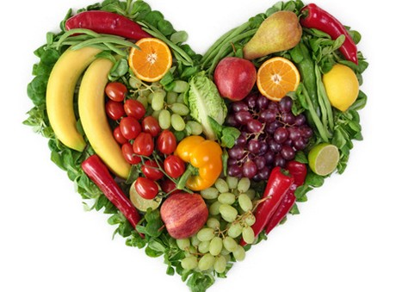

Reviewed May 2018
Next review June. 2020

Healthy Eating For All
Children's eating habits will strongly influence their chances of living a healthy lifestyle. Our healthy eating policy is intended to encourage children to practice good dietary habits. Children need a healthy diet which contains adequate energy, proteins, vitamins, minerals and fibre. This present policy was developed in consultation with pupils, parents, staff and the HPS team. As a Health Promoting School lunchbox surveys, home surveys and a suggestion box were done in preparation to amend this policy. A copy of this policy will be kept in the school office, will be given to teachers & parents and may also be viewed on the school website.

Rationale
Our school setting provides an excellent health promotion avenue for the whole school- children, families, teachers. This policy is intended as a guide to healthy and safe eating for the school. The focus of this policy is to support parents in encouraging their children to develop healthy eating habits at an early age. A knowledge of what constitutes a nutritionally balanced diet is acknowledged as being of importance for students. In support of this rationale nutrition education is considered to be an important element of the curriculum in Kildimo national school.

Aim
In the school the following steps are taken to ensure pupils and staff eat healthily:
- Children are encouraged to recognise that eating healthy food helps concentration and learning.
- Information from the new food pyramid 2017 will be given to classes so as to promote the new guidelines. This will be taught to classes in SPHE/SESE classes.
- Healthy eating is actively promoted in the school by staff and the HPS committee. There are lunch spot checks, lessons relating to healthy eating, fruit/veg breaks and assemblies.
- Parents are informed of and encouraged to support the schools healthy eating policy through the school newsletters, emails and the website.
- Parents are made aware of any healthy eating initiatives in the school and they are asked for co-operation and involvement where possible.
- Parents are kept up to date and informed through literature, healthy recipes, food diaries, healthy eating surveys etc. This ensures a home-school link.
- There are activities throughout the school to support healthy eating: Fruit and veg breaks three times a week, Healthy eating posters throughout the school, a healthy eating slogan displayed in the school, a healthy eating suggestion box, a Health Promoting School notice board and healthy eating initiatives throughout the year such as smoothie making, exotic fruit days etc.
- Lessons on oral health in conjunction with healthy eating are taught at each class level through the SPHE and SESE curriculum.
- Pupil rewards for good behaviour/birthdays are not to be food related (jellies) instead homework passes, stickers, stamps or golden time are awarded by teachers.

Guidelines

The following guidelines reflect the actions of Kildimo National School will undertake under the 4 key areas of the Health Promoting School (Curriculum & learning, Policy & Planning, Partnerships and Social & Physical environment)

WHAT WE ARE GOING TO DO

- We will support the Green schools committee by recycling at school and doing the same at home.
- Staff, students, parents will use this policy
- We will get support from outside agencies. Supertroopers (laya healthcare), food dudes, HSE.
- We will display our HPS slogan around the school on the corridors.
- We will display healthy eating posters and adverts for our fruit and veg breaks which are going on in every class.
- Includes contact with external support agencies such as Supertroopers (Laya Healthcare), Food dudes and HSE.
- We will up-date the school with new information in relation to healthy eating, such as the new food pyramid guidelines 2017.
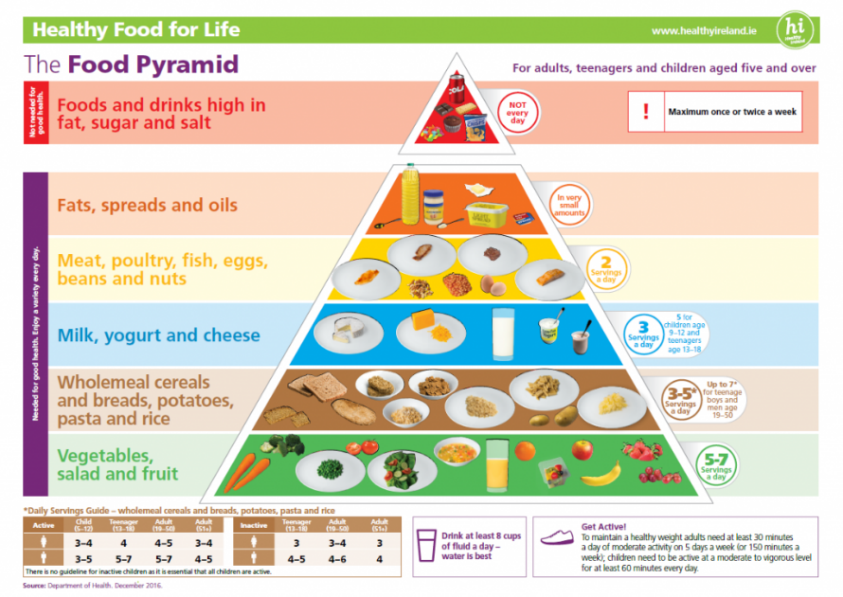

KNS Supports Healthy Packed Lunches

- There is information about healthy lunches taught under the curriculum and in information sent home to parents.
- We have access to safe drinking water via clearly labelled taps in classrooms.
- Enough time is given to pupils to eat their lunch.
- Students have an extra break designated for fruit and veg at 10am three mornings a week for five minutes.

Contents of lunch boxes.

A healthy lunch should if possible include a variety of foods from the bottom four shelves of the food pyramid. These are:
-breads/cereals
-fruit/fruit juice/vegetables
-milk/cheese/yoghurts
-meat/chicken/fish/alternatives

Please see the appendix for lunch ideas.

This policy acknowledges that water and milk are the best drinks for children –sports drinks, sugary or fizzy drinks are discouraged.
We encourage healthier choices for lunches such as brown bread instead of white and healthy snacks.
Pupils are encouraged to be involved in the preparation of their own lunch. In conjunction with this pupils are educated on food safety/hygiene when preparing and eating food. The students are encouraged to use hand sanitizer. This reflects the healthy eating message being promoted by the school.
We suggest that contents of the lunch boxes be varied.

Success criteria
The success of this policy will be assessed by:
- Observing what children have for lunch and noticing an improvement in consumption of fruit, vegetables and other healthy foods.
- The feedback from parents, guardians and other school staff.
- Repeat of the healthy eating survey.
- Limit jellies/sweets as treats in class- example offer a homework pass or golden time instead.

Ratified by Board of Management on __________________
Date

Signed __________________________________________
Chairperson, Board of Management

Appendix

• Fresh fruit (Children are conscientious about having fresh fruit for sos).
• Apples (cut in pieces for younger children, a squeeze of lemon will stop them going brown.)
• Fruit salad. (not the bar!)
• Oranges (peeled for younger children.)
• Kiwi (cut in half to eat with a tea spoon.)
• Seedless grapes
• Satsumas, clementines, tangerines.
• Small bananas.

• Crunchy Vegetables
• Include veg. Sticks with a dip.
• Cherry tomatoes
• Cucumber chunks
• Celery

• Sandwiches (should include a meat or protein filling)
Different breads add interest.
• Granary
• High fibre
• Bagels
• Fruit loaf scones
• Crisp-breads/ Crackers
• Pancakes
• Rice cakes
• Sliced bread, brown is better.
• Wholegrain
• Pitta pockets
Also try cutting the bread in different ways - triangles, squares, strips or even with shaped cutters.
Try to vary sandwich fillings each day, e.g.

• Chicken lettuce and tomato
• Goat's cheese and grated carrot
- Ham and cheese
- -Lettuce, tomato, cucumber, peppers & cheese.

Peanut /nut foods and eggs are prohibited due to the fact that some students have serious allergies.

